FINAL PROJECT PROPOSAL

“ARDUINO MIDI TRUMPET”

TERRY CHUN

Last revised 11/15/2020

**Project Description**

There are many MIDI controlled instruments that are becoming more complex and realistic as technology improves, but there is a lack of woodwind MIDI instruments in the market due to the difficulty of translating breath sensitivity to MIDI bytes.

For this project, I will be building a simple MIDI trumpet with one octave capability.

The “registers” of notes that are achieved with breath and embouchure will be achieved by using a plastic air pocket that fills the tube of the horn and activates either one of two roller switches depending on the amount of air being pushed into the instrument.

The 3-combination note valves will be replaced by 3 arcade buttons that will be programmed to have the same key fingering combinations.

The instrument will connect to Arduino by two 5-pin DMX cables, and Arduino will communicate to Processing, which will output MIDI bytes virtually to the machine.

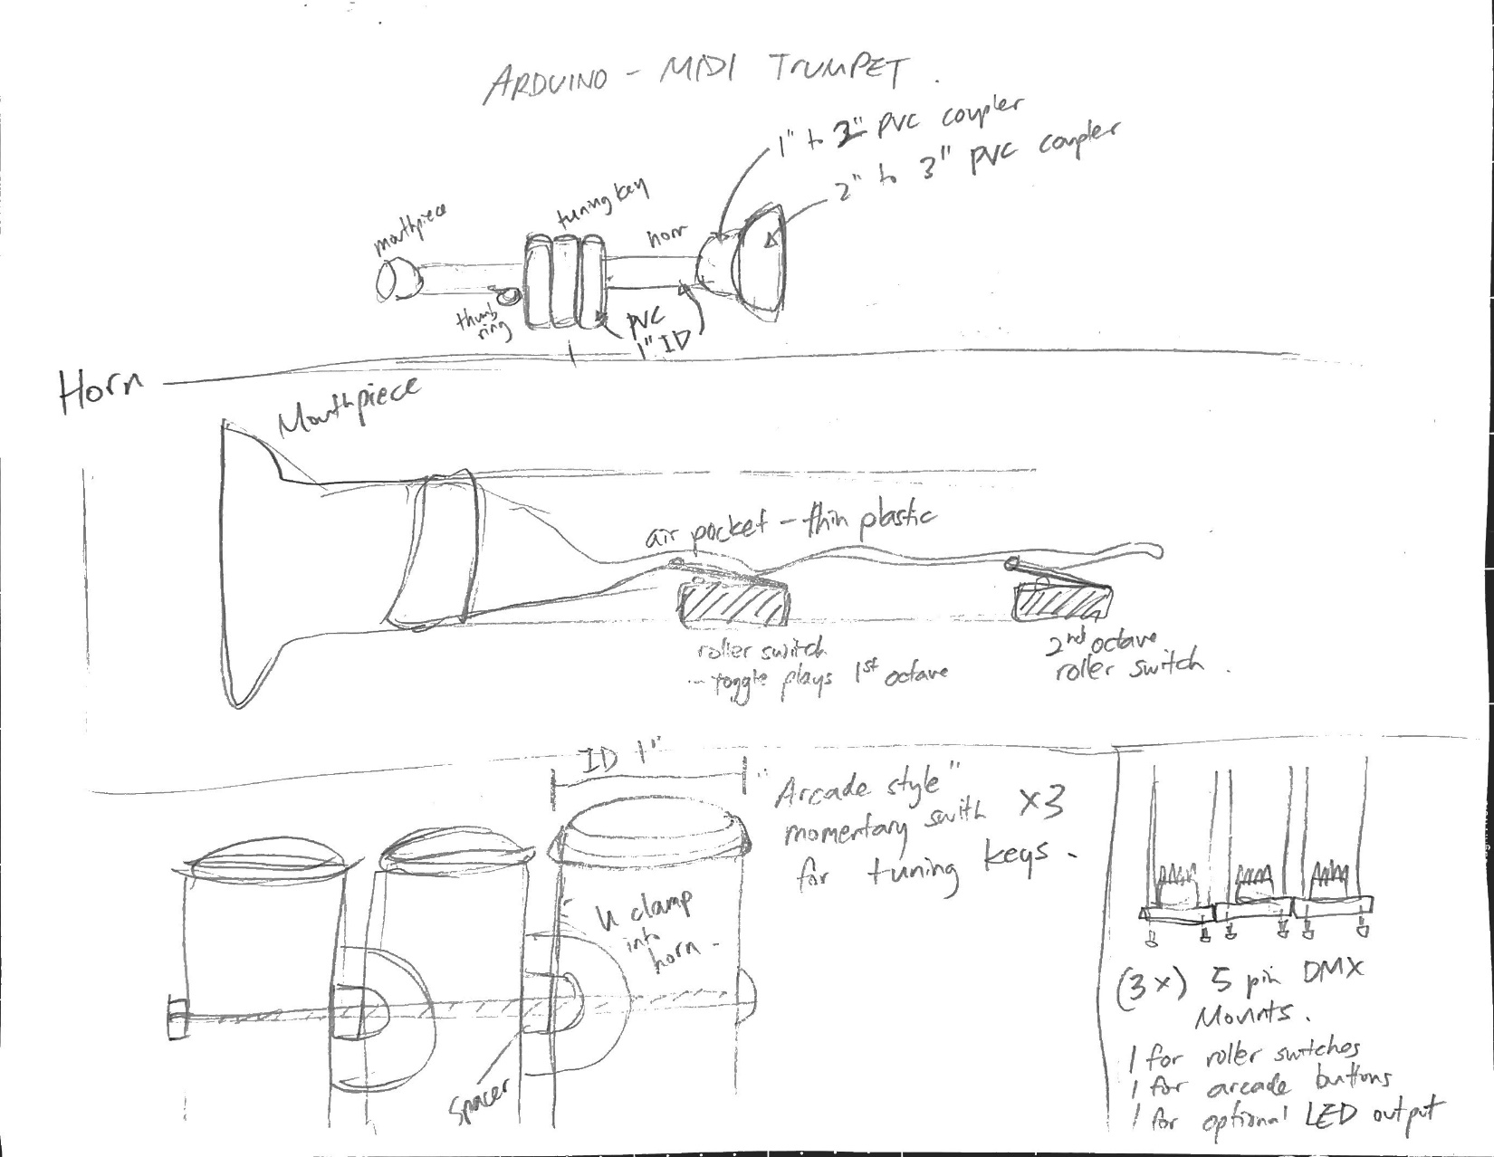

**TRUMPET BODY CONSTRUCTION**

1” Sch 40 PVC pipe for horn pipe and valve keys

Horn end – 2” x 1” PVC reducer socket end

<https://www.pvcfittingsonline.com/2-x-1-sch-40-pvc-reducer-coupling-soc-429-249.html?country=US&matchtype=&network=u&device=c&adposition=&keyword=&gclid=Cj0KCQiAnb79BRDgARIsAOVbhRrCGBUKBehF0wUPb5URZr5si_-zwoHFZ8iZLQpFIvffzGAld_VzVVYaAs_rEALw_wcB>

3” x 2” PVC reducer

<https://www.pvcfittingsonline.com/3-x-2-dwv-pvc-reducer-fitting-d102-338.html>

Mouthpiece – 1-1/2” x 1” PVC reducer bushing

<https://pvcpipesupplies.com/1-1-2-x-1-bushing-s-437-211.html?gclid=Cj0KCQiAnb79BRDgARIsAOVbhRpMP-kfQnHpYIMD_ZXeSIV2dY4_p1DO8McYgi4gp347RdW4-gSNNS8aAiTtEALw_wcB>

**SWITCHES**

(2 x) roller switches SPST

(3 x) arcade style button switch

**CONNECTORS**

(2 x) 5-pin XLR male panel mount and connectors

(2 x) 5-pin XLR female panel mount and connectors

**MISC**

Arduino UNO project box with enough room for two to three 5-pin XLR panel mount connectors

(2 x) 5-pin DMX cable

*PVC pipe constructions will be joined by bolts and nuts. Switches and other various components will be hot glued. Most will have snug fit sizes.

**SKILLS ALREADY KNOWN**

I have personally built many projects using sch 40 PVC and wiring components to fit inside.

I know how to play the trumpet and know how the end product should aim to feel.

**SKILLS TO BE LEARNED**

Need further research on how to output MIDI bytes from Processing to the computer while maintaining serial communication from Arduino.

**SIMILAR PROJECTS**

https://hackaday.io/project/2992-the-open-woodwind-project

<https://www.patchmanmusic.com/mdt.html>

<https://www.youtube.com/watch?v=A_tUe6-R26I&ab_channel=RyanEstes>

**PROJECTED CALENDAR**

**Week 1**

11/16 – Project approval

11/17 – Order all necessary parts and begin researching midi communication from Processing

**Week 2**

11/23 – Have a working note on/off midi controller using tactile switches

11/24 – As parts arrive, begin construction of the midi trumpet

**Week 3**

11/30 – Have a working prototype of the breath controlled rolling switches and arcade valve keys

12/03 – Finish first construction of the midi trumpet and begin construction of the Arduino box

**Week 4**

12/07 – Have a complete working version of the midi trumpet, begin adding LED design (optional), final testing and improving the design

12/14 – Final delivery of the finished project